ENGG1340 Computer Programming II

**Module 5 Checkpoint Exercise**

Name: Honour Oluwakorede Olatunji

University ID: 3035553484

**Instructions:**

For each single question or each group of questions in the Checkpoint exercise, please type your answer right after the question in this Word document.

**Checkpoint 5.1 (Please submit your answer to Moodle)**

Error(s) may include in the following sub-questions. If you think there is/are error(s), try to find out and suggest some way(s) to fix the error(s). If no error, please write “No error”.

a) 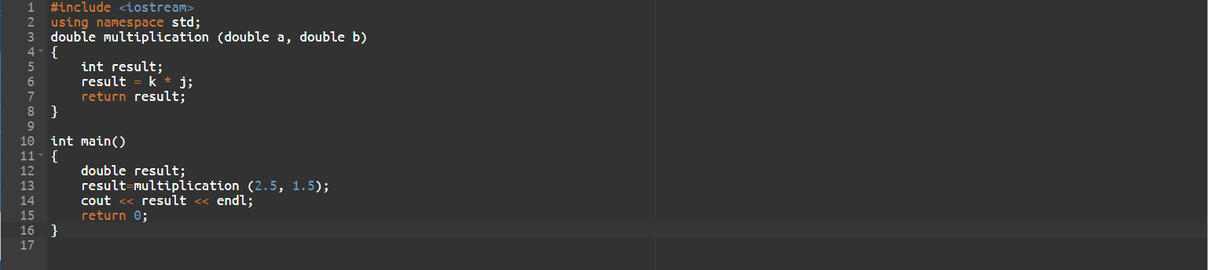

Ans:

error in line 6.

fix: result = a*b;

b)

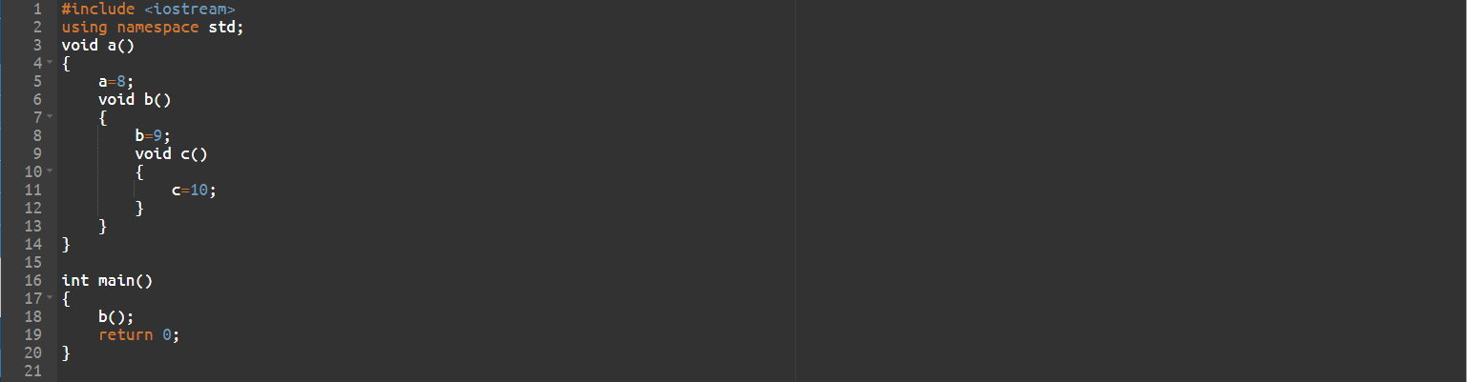

Ans:

error in lines 3-14.

fix:

void a() {

int a=8;

}

void b() {

int b=9;

}

void c() {

int c=10;

}

**Checkpoint 5.2 (Please submit your answer to Moodle)**

Write down the (i) function header; (ii) function prototype (without parameter names), for each of the following functions:

1. A function called largest that takes four double-precision, floating-point arguments, a, b, c and d, and returns a double-precision, floating-point as the result.

Ans:

1. double largest (double a, double b, double c, double d)
2. double largest (double , double , double , double );

1. A function called getPerimeter that does not take any arguments and returns an integer as the result.

Ans:

1. int getPerimeter()
2. int getPerimeter();
3. A function called setPrice that takes a double-precision, floating-point argument, price, and does not return a value.

Ans:

1. void setPrice(double price)
2. void setPrice(double);

**Checkpoint 5.3 (Please submit your answer to Moodle)**

Student A writes the following code. However, when he compiles the code, some compilation errors are found.

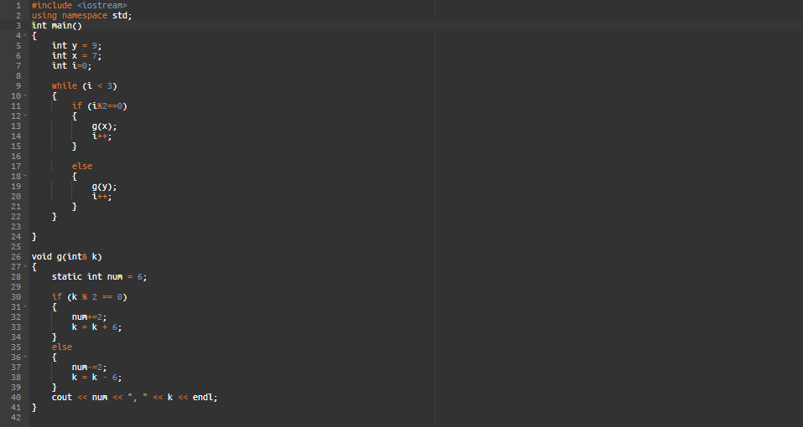

1. Find out the errors and suggest some ways to fix the errors.

Ans:

insert this code between line 2 and 3: void g(int&);

line 28 – int num = 6;

line 23 – return 0;

1. Write down the program output after you fix the errors in (a).

Ans:

4, 1

4, 3

4, -5

**Checkpoint 5.4 (Please submit your answer to Moodle)**

Given the following program:

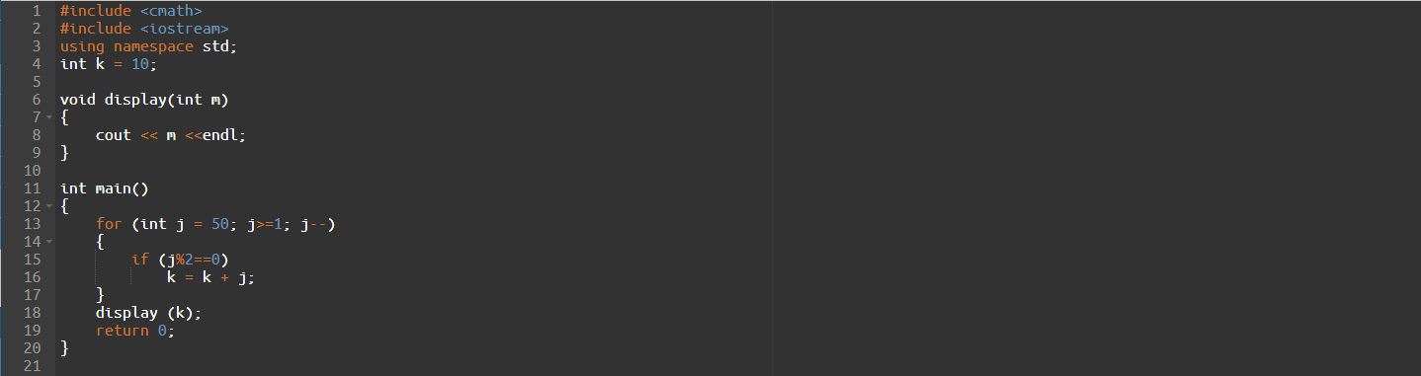

1. What is the scope of variable k?

Ans:

the whole code file.

1. What is the scope of formal parameter m?

Ans:

the void function.

1. What is the scope of variable j?

Ans:

the for loop